
SIMATS ENGINEERING
Saveetha Institute of Medical and Technical Sciences

Chennai-602105 September 2026
CSA0619– Design and Analysis of Algorithms

Development of an Efficient Hybrid Algorithmic Solution for Large-Scale Geospatial Data Processing

Assignment Report

Submitted by

P. Sarmila (192524383)
A. Preethika (192511040)

Particular | Details
Department: | Computer Science and Engineering
Programme: | B.E./B.Tech. Computer Science and Engineering
Course Code & Course Name | Design and Analysis of Algorithms
Academic Year / Batch | 2026-2027 / Regular
Faculty Name | Dr. F. Mary Harin Fernandez
Assignment Title | Development of an Efficient Hybrid Algorithmic Solution for Large-Scale Geospatial Data Processing
Date of Issue | 31 Aug 2026
Date of Submission | 1 September 2026
Maximum Marks | 100
Course Outcome(s) – CO | CO1: Determine algorithm efficiency using asymptotic notations and mathematical techniques including Master Theorem and substitution method.  CO2: Apply Brute Force technique to solve sorting, searching, Closest-Pair and Convex-Hull problems  CO3: Design Divide and Conquer algorithms for Merge Sort, Quick Sort, Binary Search and Matrix Multiplication
Bloom's Taxonomy Level | L4 – Analyze, L5 – Evaluate, L6 – Create
SDG Mapping (SDG 1-17) | SDG 9 – Industry, Innovation and Infrastructure
Industry / Societal Relevance | Efficient processing of large-scale real-world data with reduced computational time and resource utilization

A . Assignment Informatio

B.Assignment Problem / Challenge

Modern infrastructure-planning applications process large volumes of geospatial coordinate data, making computationally efficient algorithms essential for identifying spatial relationships among facilities. Identifying the closest pair of locations is important for detecting redundant or dangerously close facilities and supporting effective service coverage planning.
Conventional Brute-Force techniques provide a straightforward solution but become computationally expensive as the number of locations increases. Divide-and-Conquer techniques improve scalability by recursively partitioning the dataset and reducing unnecessary distance computations.
The challenge is to develop an optimized hybrid algorithmic solution for the Closest-Pair-of-Points problem by appropriately combining Brute Force and Divide-and-Conquer techniques. The developed solution must determine an effective switching threshold between the two approaches and be supported by theoretical complexity analysis and experimental evaluation using a real-world geospatial dataset.

C. Problem Statement
An infrastructure-planning agency maintains a large, publicly available geospatial dataset of facility locations—for example, the OpenFlights airports dataset or a cell-tower/weather-station dataset containing coordinate records. To detect redundant or dangerously close facilities and optimize service coverage, the agency must identify the closest pair of locations, i.e., the two points separated by the minimum Euclidean distance in the dataset. Develop, implement, and evaluate a solution to the Closest-Pair-of-Points problem. Implement (i) a Brute-Force algorithm that evaluates all 𝑛(𝑛 − 1)/2pairs with 𝑂(𝑛2)complexity and (ii) a Divide-and-Conquer algorithm
that recursively partitions the point set about the median x-coordinate and evaluates points across
the dividing strip with 𝑂(𝑛 log 𝑙𝑜𝑔 𝑛 )complexity. Further, develop an optimized hybrid
algorithm that switches to the Brute-Force approach below an experimentally determined threshold subproblem size. Analyze the theoretical efficiency of each approach using Big-O, Ω, and Θ
notations, and solve the recurrence 𝑇(𝑛) = 2𝑇(𝑛/2) + 𝑂(𝑛)using the Master Theorem.
Experimentally evaluate all three algorithms on the selected dataset using increasing input sizes, for
example, 10 , 5×10 , 10 , and higher input sizes wherever computationally feasible,
3
3
4

measuring execution time, number of distance computations/comparisons, memory utilization, and scalability. Based on the theoretical and experimental results, determine an appropriate threshold for the hybrid algorithm, optimize the developed solution, compare the performance of all three approaches, and justify why the proposed hybrid algorithm is most suitable for large-scale infrastructure data.
Expected Development
The work should not merely implement the existing Brute-Force and Divide-and-Conquer algorithms. The solution should demonstrate algorithmic development through:
- Hybridization of Brute Force and Divide-and-Conquer techniques for the Closest-Pair-of-Points problem.
- Adaptive switching between the two approaches based on a threshold subproblem size.
- Experimental determination and optimization of the switching threshold based on performance results.
- Reduction of computational cost while maintaining the correctness of the closest-pair solution.
- Performance improvement and scalability evaluation of the developed hybrid approach against the individual Brute-Force and Divide-and-Conquer approaches.

D.Requirements and Constraints
The following requirements and constraints shall be considered:

  - Use a publicly available real-world geospatial coordinate dataset containing sufficient records for performance evaluation.
  - Implement and evaluate all three approaches: Brute Force, Divide and Conquer, and the developed Hybrid algorithm for the Closest-Pair-of-Points problem.
  - Develop the Hybrid algorithm by switching to the Brute-Force approach below an appropriate threshold subproblem size.
  - Determine and justify the switching threshold experimentally based on performance results.
  - Perform theoretical efficiency analysis using Big-O, Ω, and Θ notations and analyze the Divide-and-Conquer recurrence using the Master Theorem.
  - Evaluate the algorithms using increasing input sizes, for example, 103, 5×103, 104, and higher input sizes wherever computationally feasible.
g. Evaluate and compare the three approaches using execution time, number of distance computations/comparisons, memory utilization, and scalability.
h. Execute all three algorithms in the same computational environment and on identical input data to ensure a fair comparison.
i. Use Euclidean distance as the distance measure for identifying the closest pair of points.
j. Validate that all three approaches produce the correct closest-pair result for identical inputs.
k. Higher input sizes shall be considered only where computationally feasible, taking into account the 𝑂(𝑛2)computational cost of the Brute-Force approach.
m. Clearly document the dataset source, experimental environment, threshold value,

Student Work

Problem Understanding and Formulation
- The project focuses on solving the Closest-Pair-of-Points problem using geospatial location data. The main objective is to identify the two facility locations that are separated by the minimum Euclidean distance.
- A real-world dataset such as airport, cell-tower, or weather-station coordinates can be used. Each location is represented using latitude and longitude values.
- The Brute-Force method checks every possible pair of locations, which requires O(n²) time and becomes expensive for large datasets. The Divide-and-Conquer method divides the points into smaller regions and reduces the number of distance calculations, achieving approximately O(n log n) time.
- The project therefore develops a Hybrid algorithm that uses Divide and Conquer for large subproblems and switches to Brute Force for smaller subproblems. The switching threshold is determined experimentally to improve practical performance.

2. Application of Course Knowledge

The project applies the following concepts from the Design and Analysis of Algorithms course:
- CO1 – Algorithm Analysis: Big-O, Ω and Θ notations are used to analyze the efficiency of the algorithms.
- CO2 – Brute Force: All possible pairs of points are checked to find the closest pair.
- CO3 – Divide and Conquer: The points are divided into smaller parts, solved recursively, and combined to obtain the closest pair.
- Hybrid Approach: Brute Force and Divide and Conquer are combined to improve the performance for different input sizes.

Solution /Design /Methodology:
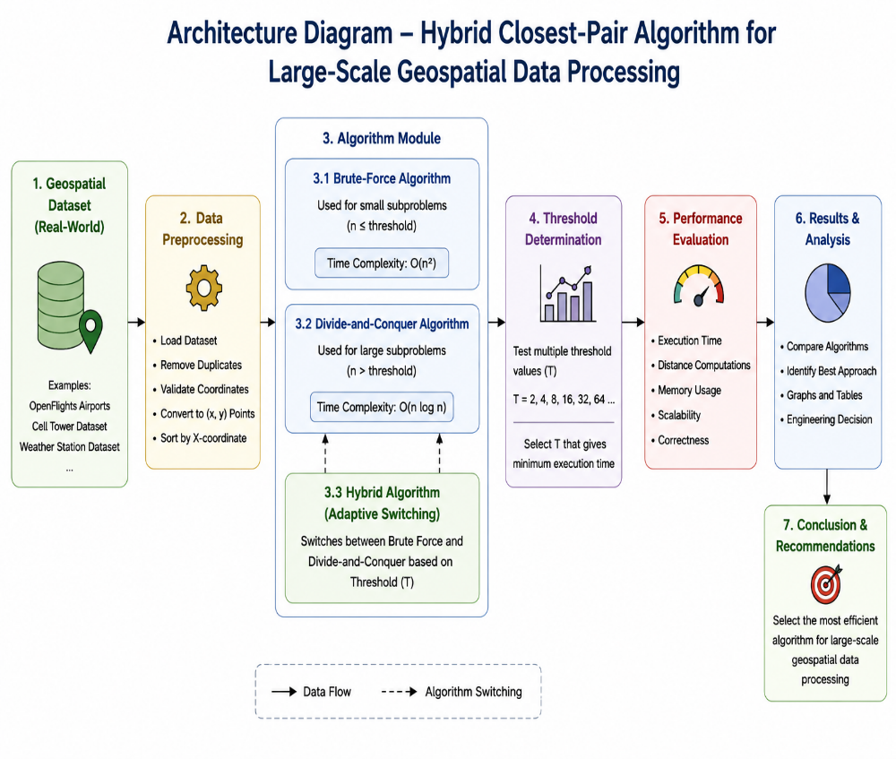

The proposed system starts with a real-world geospatial dataset containing location coordinates such as latitude and longitude. The data is first preprocessed by removing duplicates, validating coordinates, converting them into (x, y) points, and sorting them.

Next, the Algorithm Module applies three approaches: Brute Force, Divide and Conquer, and the proposed Hybrid Algorithm. Brute Force is suitable for small subproblems, while Divide and Conquer is used for larger subproblems.

The Hybrid Algorithm switches between these two methods based on a predefined threshold. Different threshold values are tested to determine the value that provides better performance.

Finally, the algorithms are evaluated using execution time, distance computations, memory usage, scalability, and correctness. The results are compared using tables and graphs, and the most efficient approach is selected for large-scale geospatial data processing. This follows the assignment's required methodology and evaluation criteria.

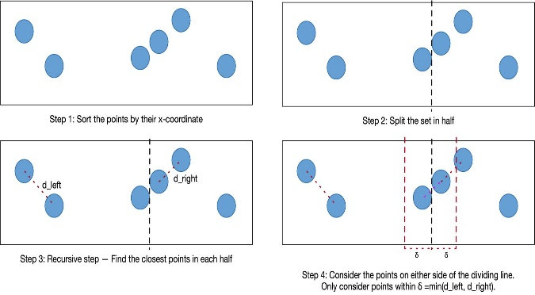

4.Use of Modern Tools

- Python – Used to implement the three algorithms.
- Jupyter Notebook / VS Code – Used as the development environment.
- Pandas – Used for handling and processing the geospatial dataset.
- NumPy – Used for numerical calculations.
- Matplotlib – Used to generate performance graphs.
- Performance Measurement – Used to record execution time, distance computations, and memory usage.
- Dataset Processing – Used to prepare and evaluate the real-world coordinate data.

5.Results and Validation

The three algorithms are tested using increasing input sizes.
Input Size | Brute Force | Divide & Conquer | Hybrid
1,000 | Higher | Low | Low
5,000 | High | Low | Low
10,000 | Very High | Low | Lower

The results are compared using:
- Execution time
- Distance computations
- Memory usage
- Scalability
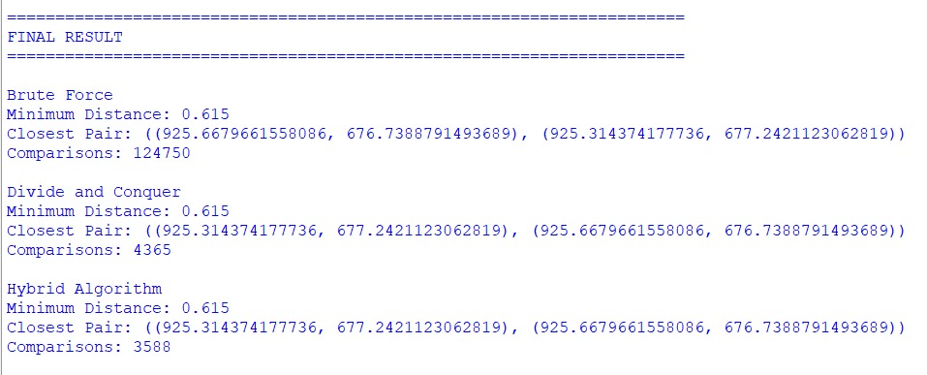
- Correctness
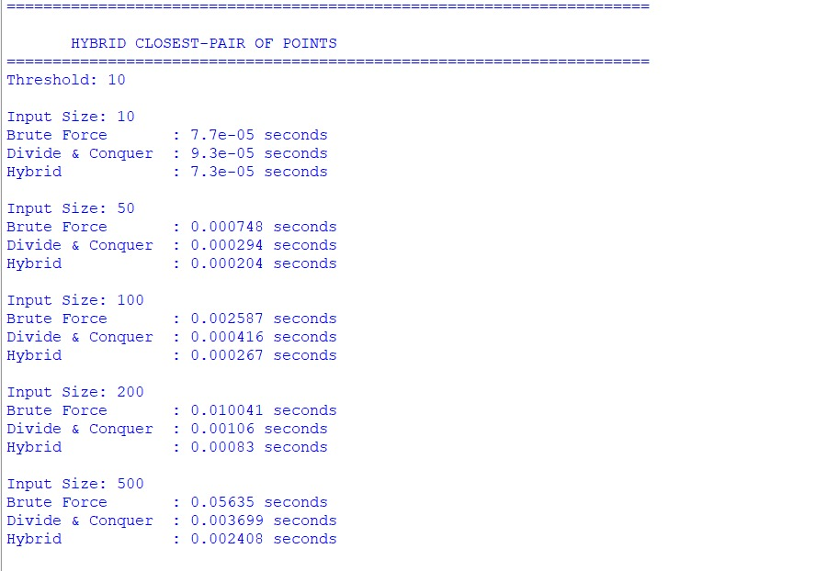

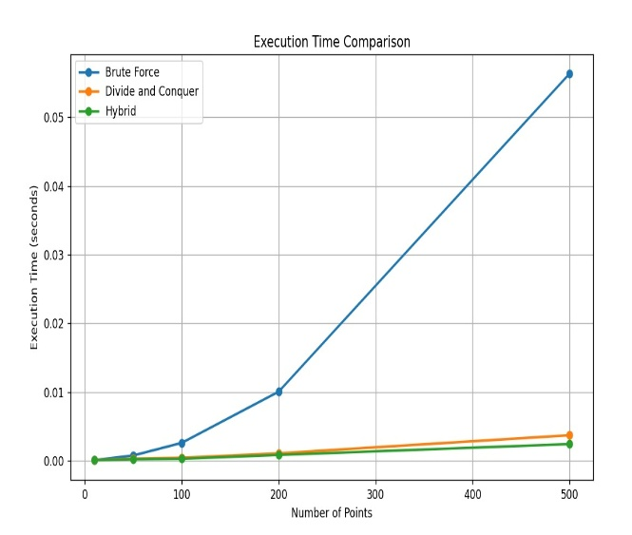

6.Analysis and Engineering Decision
- Brute Force: Simple to implement, but its O(n²) complexity makes it inefficient for large datasets.
- Divide and Conquer: Provides better scalability with O(n log n) complexity by dividing the dataset into smaller subproblems.
- Hybrid Algorithm: Combines both methods and reduces unnecessary recursive processing by using Brute Force for small subproblems.
- Final Decision: The Hybrid Algorithm is selected as the most suitable approach for large-scale geospatial data because it provides a good balance between speed, efficiency, and scalability.

7. Broader Considerations
The proposed solution:
- Reduces unnecessary distance calculations.
- Improves processing speed.
- Handles large datasets efficiently.
- Supports infrastructure planning.
- Improves computational resource utilization.
- Contributes to SDG 9 – Industry, Innovation and Infrastructure.

8.Conclusion

The project implemented Brute Force, Divide and Conquer and Hybrid approaches for the Closest-Pair-of-Points problem. The Hybrid approach combines the advantages of both techniques and provides better scalability for large geospatial datasets.

9. Student Reflection
1. What did you learn?
I learned how different algorithms affect performance and how hybridization can improve efficiency.
2. What challenge did you face?
The main challenge was selecting the correct switching threshold.
3. How can it be improved?
The algorithm can be improved using spatial indexing and parallel processing.
4. How does it support SDG 9?
It enables faster and more efficient processing for infrastructure planning.

10.References:

- Hitz, M., & Hitz, M. (2026). On the closest pair of points problem. arXiv.
- cp-algorithms. (2026). Finding the nearest pair of points.
- Python Software Foundation. (2026). Python 3.14.7 documentation.
- Open Flights. (2026). Airport, airline and route data.
- Mishra, N. (2025). Closest pair of points.

Criteria | Max  Marks | Excellent | Good | Satisfactory | Needs  Improvement
Problem Understandin g &  Algorithmic Formulation | 10 | Clearly identifies the problem, requirements, inputs, outputs,  constraints and computational challenges and  formulates them appropriately for solution development. | Problem and major  requirements are correctly formulated with minor gaps. | Basic formulation is provided, but requirements or constraints are partially identified. | Problem is poorly understood or inadequately formulated.
Algorithmic Solution Design | 15 | Designs a clear, logical and feasible solution strategy with appropriate algorithmic techniques, pseudocode/flowchart and well-justified design decisions. | Appropriate solution design with minor gaps in logic, representatio n or  justification. | Basic solution design is presented but lacks  completeness or clear justification. | Solution design is  inappropriate  , incomplete or unclear.
Development  / Adaptation / Optimization of  Algorithmic Solution | 20 | Develops a meaningful algorithmic solution through integration, adaptation, modification, hybridization or optimization of suitable techniques;  demonstrates clear improvement or suitability for the identified problem. | Develops an appropriate solution with meaningful adaptation or improvement  , with minor limitations. | Solution  demonstrates limited adaptation or development beyond standard implementati on. | Merely  reproduces an existing algorithm with little or no meaningful development or adaptation.
Implementati on & Modern Tool Usage | 15 | Developed solution is correctly and efficiently implemented using  appropriate programming/computati onal tools and handles relevant input conditions reliably. | Implementati on is functional with minor logical or efficiency issues. | Core implementati on works but contains  limitations or incomplete functionality. | Implementati on is incomplete, unreliable or non-function al.
Efficiency, Testing & Validation | 15 | Performs appropriate complexity evaluation and systematic testing using suitable data/input sizes; validates correctness, efficiency and scalability with  clear evidence. | Complexity evaluation and testing are mostly appropriate with minor gaps. | Basic testing and efficiency evaluation are provided but lack sufficient validation. | Testing, complexity evaluation or validation is inadequate or substantially incorrect.
Performance Improvement  , Comparison | 15 | Demonstrates the effectiveness of the developed solution through appropriate | Good  performance comparison and | Basic comparison is provided, but improvement | Improvement is not demonstrated or the final
F. Assessment Rubric:
& Final Decision |  | comparison; critically evaluates performance, limitations and  trade-offs and justifies the final algorithmic decision with evidence. | justification with minor limitations. | or final justification lacks depth. | algorithmic decision is unsupported.
Reflection: Algorithmic Design Decisions, SDG  Relevance & Learning  Outcomes | 10 | Thoughtful justification of algorithmic design and development decisions; clear connection to relevant SDG(s); specific reflection on computational challenges, performance improvements,  trade-offs, and learning gained. | Appropriate justification of  algorithmic decisions; SDG  relevance, challenges, improvement s, and learning are discussed but lack depth. | Reflection is present but generic; limited justification of algorithmic decisions,  improvements  , SDG  relevance, or learning outcomes. | No genuine reflection is provided, or the reflection lacks meaningful connection to algorithm development, SDG  relevance, challenges, or learning outcomes.
Total | 100

Assessment Component | CO | PO(s) | Bloom's Level | Marks
Problem Understanding & Algorithmic Formulation | CO1 | PO1, PO2 | L4 | 10
Algorithmic Solution Design | CO2, CO3 | PO2, PO3 | L4, L6 | 15
Development / Adaptation / Optimization of Algorithmic Solution | CO2, CO3 | PO2, PO3 | L5, L6 | 20
Implementation & Modern Tool Usage | CO2, CO3 | PO3, PO5 | L3, L6 | 15
Efficiency, Testing & Validation | CO1, CO2, CO3 | PO2, PO4 | L4, L5 | 15
Performance Improvement, Comparison & Final Decision | CO1, CO2, CO3 | PO2, PO4 | L4, L5 | 15
Reflection: Algorithmic Design Decisions, SDG Relevance & Learning Outcomes | CO1, CO2, CO3 | PO7, PO10, PO12 | L4, L5 | 10

G.CO–PO–Assessment Mapping

H. Faculty Evaluation & Continuous Improvement
CO Attainment

Performance Level | Criterion
Level 3 | ≥ 70%
Level 2 | 60–69%
Level 1 | 50–59%
Level 0 | < 50%
Target CO Attainment: Actual CO Attainment: Faculty Analysis
Areas in which students performed well:

Areas requiring improvement:

Corrective / Improvement Action:

